 | Hkkjrh; izksS|ksfxdh laLFkku xqokgkVh  Indian Institute of Technology Guwahati  Guwahati 781 039, India

Dean (Students’ Affairs)
Sl. No. | Name | Period
Sl. No. | Name | From | To
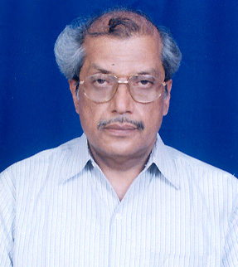 | Prof. Mihir Kumar Choudhuri | 1998 | 23.3.2003
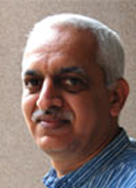 | Dr. Ravi Mokashi Punekar (Associate) | 24.03.2003 | 2004
 | -------------- | 2004 | 2005
 | Prof. A. Srinivasan | 2005 | 3.9. 2006
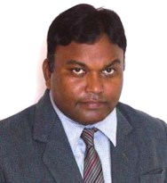 | Dr. S. Dandapat | 04.09.2006 | 30.6.2008
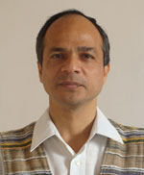 | Dr A.K Sarma | 01.07.2008 | 8.8.2011
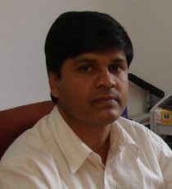 | Dr. B.K. Patel | 09/08/2011 | Till Date

